**Pharmacy Management System**



Powered By ZeonIt

**Content**

1. Introduction about the Pharmacy management System .
2. Purpose .
3. Scope .
4. Objectives .
5. Modules of pharmacy Management system .
6. Features of Pharmacy Management System .
7. Functional Requirements .
8. Non Functional Requirements .

**1.Introduction about the Pharmacy management System**

Now day’s Information And Communication Technology (ICT) plays a great role in different fields or area among thus Health care System belong to this. This leads to various studies and researches being conducted to selected health care facilities . it is necessary to ensure to a technologically appropriate , equitable , affordable ,efficient and environmentally adaptable and consumer friendly system . design to fully utilize the ICT for the maximum benefit in the health care industry .

Here Computer are great relevant on storing data’s securely and ease access on them in short period of time.

In Order to exploit the ICT in health care system , Pharmacy management System is being build . pharmacy Management system is robust , integrated technology . Pharmacy management System deals with the maintenance of drugs and consumable’s in the pharmacy unit . The setup of the Pharmacy management System will ensure availability of sufficient quantity of drugs and consumable materials for the patient . this will enhance the efficiency of clinical work and ease patient’s convenience , bearing in mind that in Ethiopia is heading towards pharmaceutical care of patients. In addition pharmacy Management system will be able to process drug prescription with ease . PMS (Pharmacy management System) will design to detect drug interaction .

In general, the Pharmacy management System is based on computer technology that gives service for users . managed by the pharmacies who give implementation of function relatively in effective times as well as will designing for removing time wasting, saving resources , easy data access of the medicine . security on data input and data access by removing almost manual based system.

**2.Purpose**

The Pharmacy management System is built for the sake of ensuring effective and clear data saving and manipulating as well as next work on the pharmacy medical Products . This refers the PMS project highly minimize time and resource by which searching the medicine data you can get the data in quickest time. And almost the resources are wise used since most actions are done on the pharmacy system . some of the resources minimized include paper . manpower and related things .The other thing is for storing data’s in secure way .

A Summarized list of drugs dispensed to patient can be viewed for monitoring purpose also PMS will be able to generate report on the list drugs dispensed in the polyclinic for a given time period and there is a message alert for the user if the stock holding quantity reaches a low level .Thus , the Pharmacist will need to replenish the drugs .

**3.Scope .**

With the development of specific and potent synthetic drugs , the emphasis of the pharmacist’s responsibility has moved Substantially towards the utilization of scientific knowledge in the proper use of modern medicines and the protection of the public against dangers that are inherit in their use .

pharmacist’s are employed in regulatory control and drugs management community pharmacy , hospital pharmacy , pharmaceutical industry , academic activities , training of other health workers, and researches. In all these fields , their aim is to ensure optimum drug therapy , both by contributing to the preparation supply and control of medicines and associated products , and by providing information and advice to those who prescribe or use pharmaceutical products .

**4.Objectives .**

It is the user friendly application for pharmacist which reduces the burden and helps to manage all sections of pharmacy like medicine management and Billing etc… which improve the processing efficiency . it deals with the automating tasks of maintaining off bills .In pharmacy , Billing Management id the key process . Including safe data store about medicine as well as fast searching delete and update of medicines . The PMS is easy for use so the user can do pharmacy actions without ambiguities .

The main Objectives of the PMS is making the pharmacy organization computerized by creating neat work through minimizing and eliminating wasting of time as well as removing the resources such as paper for data saving since know a drug is paper based , decrease malfunctioned work on the medical usage by giving correct information on each medicine .

**5.Modules of pharmacy Management System .**

**Customizable software & generates Reports:** The software is easily customizable and is also capable of generating various reports.

**Medicine Purchase Request & Order:** It is to manage the purchase requests and order requests received for the medicines.

**Drug issue to Patients & Billing:** This is to maintain the record of drugs issued to patients and also the billing that took place during the day/month/year.

**Physical stock verification & adjustment:** This module is responsible to verify the physical stock and the decision, regarding adjustment (if required) can take place.

**Supplier & Manufacturer Information:** It is again vital as this keeps a record of the supplier/manufacturer information from whom you buy the medicines/who is responsible for the manufacturing of those medicines.

**Reports about stock-in-Hand & complete details of Medicines:** It gives the information of the stock that is in-hand with entire medicine details.

**Maintenance of Medicine Stock:** Future decisions can easily be taken on basis of this, by maintaining the medicine stock as this way you know when the stock needs to be updated.

**Destruction of Expired Items:** It is again vital to have the information of expired items that need to be destructed so that the process can be held timely.

**Return of items nearing Expiry:** There is a record of items nearing the expiry date, so this way they can be returned on time.

**Automatic Reorder Level/Minimum Stock Setting:** There is a module in the system of minimum stock setting, so that can be activated by mentioning a minimum stock and Automatic reorder level refers to the quantity threshold at which your software will automatically a new order for stock.

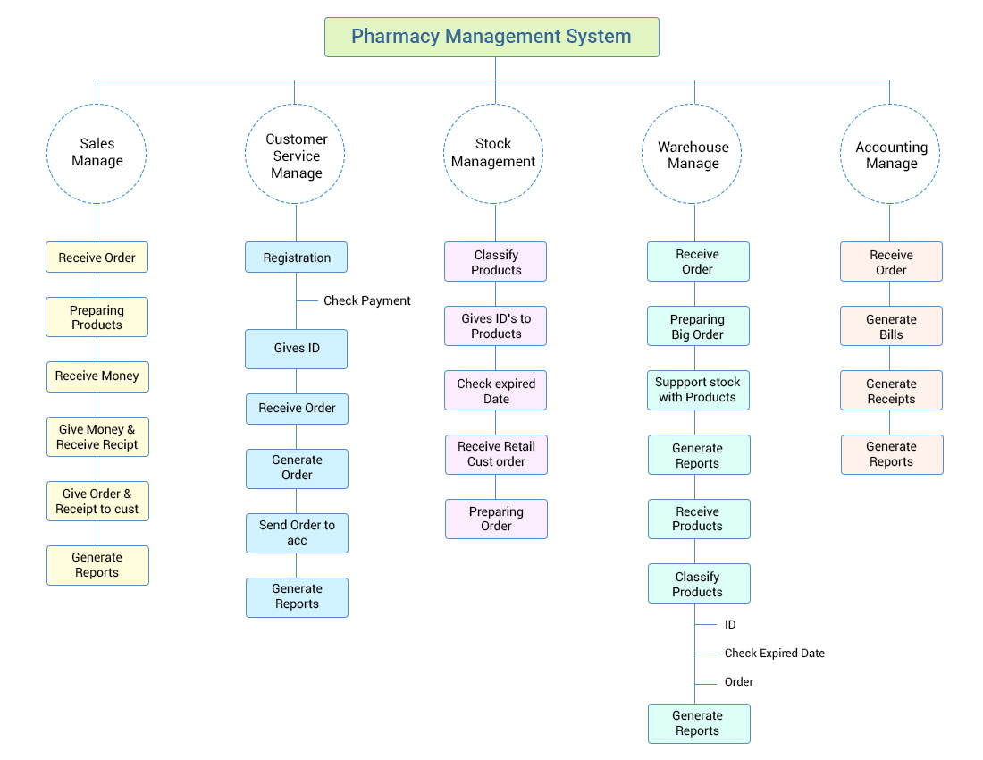

**6.Features Of Pharmacy management System .**

In case of Pharmacy Management Software, the developing company desires for it to be complex and robust. Like, it should be able to track inventory, generate several reports, manage workflow, manage complex billing adjudications in real-time, keep track of comprehensive dispensing data and a lot more. It involves dozens of essentials features so, let’s explore them here.

* **User-Friendly input & recall of Patient, Drug & Prescription information:**This system is quite user-friendly and is has the ability to keep a record of patient, drug & prescription information, which is certainly come useful for future purchases or other purposes.
* **HIPAA and regulatory compliance:** It goes without saying that the system must be aligned with legal requirements in the field hence it must comply with HIPAA & regulatory compliance (consisting of FDA required Med Guides & DEA Reporting.
* **Full prescription management:** As integrated with [prescription](https://www.octalsoftware.com/e-prescribing-eRx-solutions),The system offers to manage the full prescription given by the doctors.
* **Automated claims Processing:** Of course, the system requires automated claim processing systems and it keeps an entire record of the claim submissions including adjudication (V5.1, etc.)
* **Accuracy & Safety:** As it is the question of many lives, hence the system offers the fail-safe features for accuracy & safety, hence leaving no scope for errors.
* **Complete & accurate drug interaction & other databases:** The system is able to detect Drug-Drug Interactions and this way it reduces the chances of ADEs, preserves patients’ safety, and prevents related medical and legal problems.
* **A/R management:** Account Receivables Management is crucial in the arena of healthcare to ensure the smooth & successful functioning and that owed amount is refunded back in the shortest time possible. It looks after denied claims and reopens them to receive maximum reimbursement.
* **On-line reconciliation:** It’s a cost-effective feature to increase cash flow, reduce write-offs and costs. This is vital in increasing profits & revenues.
* **Drug-file updates:** All the updates regarding the new drugs introduced in the market and other drugs related information can be found in the system.
* **Auto Dr. Fax:** It allows your doctor to call in or fax patient’s refill to the pharmacist, saving patient’s trip to the Pharmacy.
* **Tailored labels:** This feature facilitates customized prescription drug labels, hence making the handlings a lot easier.
* **Electronic wholesaler ordering:** This feature ensures up-to-date costing and inventory, which ties into reliable margin reporting and inventory valuations.
* **Reporting:** As the month ends, you should be able to tally the revenues generated by stock movement. You need to be informed of the sale of each unit of an inventory, also what has been disposed or damaged. Hence you can ensure that you don’t lose even a penny without it being accounted for.

**7.Functional Requirements .**

There are functions done by the system such as store the necessary information of drugs prepare bill for the medicine , give week reports , easily Searching of medicine , working in two languages update, delete and save data’s of medicine .

**Store the necessary information of the drugs**

The Pharmacy System stores the detail information about catch medicine including actual name, formula of medicines and how it in importance and for which diseases is required. Since the information for each drug were required in some cases like these of drugs when use drugs and for whom is given .

**Search Medicine and other details**

The Pharmacy System has easily searching of medicines which shows in which shelf is put and behavior of the medicine .The Searching process is based on the name of the give data or the identification of the item.

**Alerting Pharmacy detail in the system**

Changing medicines another become of medicine outdated , modifying the saved medicine data for incorrect data deleting of data’s of the pharmacy can be done on the system .

**Support only English**

The System supposed work on primarily in English so the user can use only these language .

The Function what the system do is :

* Store medicine data’s
* Search medicine data effectively
* Update , delete and edit medicine information
* Generate report on medicine
* Gives navigated or information for pharmacy organization
* Give alert for the user when medicine item is low
* Changing login password
* Have the System document how to use the system

**8. Non Functional Requirements .**

This Pharmacy management System is able to operate in the following characteristics .

**Usability**

Any familiar in using windows operation can be operate the system since it have user friendly user interface which have the instruction menu is how to use it which self directive application the can be used the system without ambiguity .

**Reliability**

The Pharmacy system is available based on the user needs can work properly and do transaction efficiency including safe data management of the pharmacy for invalid and malfunctioned operation the system will restart in order to prevent data loose as well as safe operation within 5 seconds The PS is on the system . here the pharmacist manage control over the system by login to the pharmacy System . Any User can’t use the system but the guest user can see on general properties of the pharmacy and medicines without password . as result data is protected and controlled by only the administrator .

**Performance**

The Pharmacy Management System operated its function in small amount of time which is less than two seconds and an be accessed by one user at a time or concurrently to access the which must have the pharmacy System privileged and also the system can store data up to 40GB data .When the system may be busy due to malfunction operation it may wail up to one minute other ways the pharmacy system restart .

**User Interface**

The user interface friendly which is easy to use and having attractive frame structure which is prepared in assumption with other related system Also the user can changed user favorite interfaces that is available in the system .

**Operation**

The pharmacy management system is operated and controlled by the pharmacy management for safe work .